Chapter 8 – Earth Systems

Reading Guide
Vocabulary
Learn the definition of each term. The bold words require you to know more than just the definition. For example: Ecosystem service - you should what they are, be able to name several types and describe how we benefit from those services.

Core
Mantle
Asthenosphere
Lithosphere
Crust
Hot spots
Plate Tectonics
Oceanic Plates
Continental Plats
Seafloor spreading
Subduction
Divergent boundary
Convergent boundary
Transform boundary
Fault zones
Earthquake
Epicenter
Ring of Fire
Richter scale
Minerals
Rock cycle
Igneous rocks
Sedimentary rocks
Metamorphic rocks
Physical weathering
Chemical weathering
Erosion
Deposition
Ores
Metals
Known reserves
Strip mining
Tailings
Open-pit mining
Subsurface mining
Mining spoils (tailings)
Mountaintop removal
Mining Law of 1872
Surface Mining Control and Reclamation Act of 1977
Smelting
Gangue
Area strip mining
Contour strip mining
Acid Mine Drainage

Reading Outline

Are Hybrid Electric Vehicles as Environmentally Friendly as We Think?

- List the environmental pros and cons of hybrid cars.

8.1 The availability of Earth’s resources was determined when the planet formed

- Fill in the chart below for the layers of the earth. Do your best given that several of the layers overlap.
Layer | State (solid, liquid, etc) | Made of | Order (from outside to inside)
Asthenosphere
Crust
Inner core
Lithosphere
Mantle
Outer Core

8.2 Earth is dynamic and constantly changing
- Fill in the chart below for the different geologic features on earth
Feature | Image | Results in | Where found? | Example
Hot Spot | 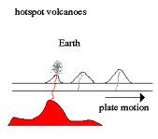  http://abyss.uoregon.edu/ ~js/images/hotspot.gif | Volcanoes | In the middle of plates | Hawaiian Islands
Sea Floor Spreading
Subduction
Volcano
Divergent Plate boundary
Convergent plate boundary
Transform fault boundary

- What are the differences between oceanic and continental plates?

- What environmental impacts do earthquakes cause? How can we protect humans during and after an earthquake?

- What environmental impacts do volcanoes cause? How can we protect humans during and after a volcano?

8.3 The Rock Cycle
- Go to http://www.learner.org/interactives/rockcycle/change.html and complete the Rock Cycle Tutorial. Explain how each type of rock and can change into another type.

8.4 Uneven distribution of mineral resources
- What three elements (IN ORDER) make up the Earth’s crust?

8.5 Types of Mining
- Mining Methods Fill out the following chart on mining methods. You might like the following videos in addition to your textbook.
- Surface Mining: http://www.youtube.com/watch?v=2LQwxTm94Ps
- Subsurface Mining: http://www.youtube.com/watch?v=Bk-jrbCi7Sc&feature=related
- Area Strip Mining: http://www.hippocampus.org/AP%20Environmental%20Science
- Open Pit Mining: http://www.hippocampus.org/AP%20Environmental%20Science
- Mountain Top Removal: http://www.youtube.com/watch?v=9Z0RzDEPF6E
- Ore Processing: http://www.hippocampus.org/AP%20Environmental%20Science

Mining | Type  (surface, subsurface, underwater) | Used to mine for: | Description | Environmental Impacts
Dredging

Area Strip Mining
Contour Strip mining
Open pit mining
Underground coal mining
Mountain Top Removal

- What three elements (IN ORDER) make up the Earth’s crust?

- What do the Mining Law of 1872 and the Surface Mining Control and Reclamation Act of 1977 do?

- What are the basic steps in reclaiming a mining site?

Additional Work:
Answer the MC questions at the end of the chapter and review the FRQs.

Chapter 9 – Water Resources

Reading Guide
Vocabulary
Learn the definition of each term. The italicized words are not necessarily in the textbook (Check the lecture). The bold words require you to know more than just the definition. For example: Ecosystem service - you should what they are, be able to name several types and describe how we benefit from those services.

Aquifer
Watershed
Unconfined aquifer
Confined aquifer
Artesian Well
Water table
Recharge zone
Cone of Depression
Salt water intrusion
Subsidence
Floodplain
Oligotrophic lake
Mesotrophic lake
Eutrophic lake
Impermeable surfaces
Levee
Dike
Dam
Reservoir
Fish ladder
Aqueduct
Desalination
Distillation
Reverse osmosis
Furrow irrigation
Flood irrigation
Spray irrigation
Drip irrigation
Hydroponics
Gray water
Tiered water pricing system
Xeriscaping

Disasters
Aral Sea
Three Gorges Dam
Ogallala Aquifer
James Bay Project
CA water project
Colorado River
Aswan Da

Reading Outline

Dams and Salmon on the Klamath River
- What caused the drop in Salmon populations in the Klamath River?

- Who are the major interest groups competing over the Klamath River, and what does each one want?

- How was the conflict over Salmon and water in the Klamath River resolved?
10.1 Water is abundant, but usable water is rare

- Label the diagram below by matching the letters to the terms
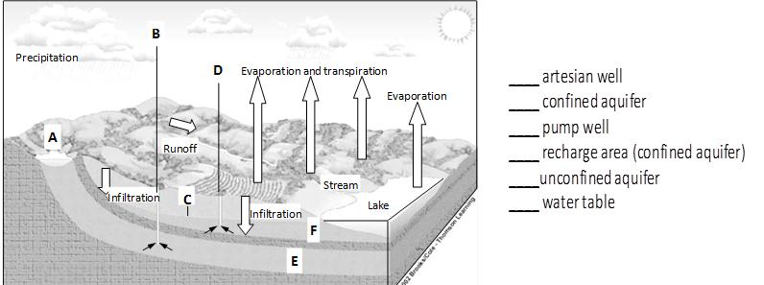

- Why are unconfined aquifers more likely to be contaminated than confined aquifers? Why are confined aquifers more likely to be depleted than unconfined aquifers?

- Describe two negative effects of overpumping groundwater.

- How can lakes form? Give a few examples.

- Eutrophication is a natural aging process for lakes, but when humans cause it, it is called cultural eutrophication. What are the differences between natural eutrophication and cultural eutrophication?

- Match the name to each description. Choices: oligotrophic lake, mesotrophic lake, eutrophic lake
- _________________________________ - Highly productive ecosystem with high levels of organic matter, murky water and thick mud on the bottom. Oxygen levels may be depleted and desirable fish populations are often low.
- _________________________________ - A deep lake with clear water that has low productivity, little organic matter and high oxygen levels. Desirable fish populations are usually abundant and the lake is visually attractive.
- _________________________________ - A productive ecosystem that has some organic matter, medium nutrient levels and somewhat clear water. A thick layer of decomposing organic matter is forming on the bottom of the lake and plants may be growing in the shallow zones near the lake boundaries. On particularly hot sunny days, oxygen levels may drop, but in general the lake has the oxygen to support desirable fish populations.

- List the negative impacts of a drought.

- Describe some ways that humans contribute to droughts.

- How do humans contribute to flooding?

9.2 Humans can alter the availability of water
- Fill in the chart below for ways humans alter waterways.
Engineered Structure | Description | Purpose | Benefits | Drawbacks
Levee
Dike
Dam
Aqueduct

- Summarize each of the following water related case studies. Include what happened, where and why, the environmental impacts and any human health or economic impacts.
  - Hurricane Katrina and the New Orleans Levees

  - Three Gorges Dam

  - Aral Sea Disaster

  - Ogallala aquifer

- What is desalination or desalinization? Describe both processes: distillation and reverse osmosis.

9.3 Water is used by humans for agriculture, industry and household needs

- Worldwide, list the three top uses of water, in order including percentages.

- Put the 4 irrigation techniques in order from most efficient to least efficient.

- How does hydroponic agriculture works? What are the benefits and drawbacks?

- Describe 3 different ways industry uses water.

- What three household activities have the largest impact of water consumption in the United States?

- In the US, we rarely think about our drinking water. Why would someone in a less developed country think about drinking water on a daily basis?

9.4 The future of water availability depends on many factors
- Water ownership is complicated.
  - Why is it harder to determine ownership of water than for many other resources?

  - Briefly describe 3 water conflicts (from this chapter or previous units).

  - How do economists suggest that we resolve these conflicts?

- What methods have wealthier, developed countries made to conserve water? Describe one option for each of the following activities:
  - toilet flushing -
  - bathing -
  - laundry -
  - outdoor usage -
  - industry -
  - runoff -

- How do recent trends in global water consumption compare with recent trends in US water consumption? Given these trends, what do you think will happen to global water use in the near future?

- What is grey water? What can it be used for? Are there any concerns about re-using grey water?

- What kinds of household water would not be reusable without treatment?

Additional Work: Answer the MC questions and Measuring Your Impact at the end of the chapter.

